Customer Shopping Behavior Analysis
1. Loading the Dataset
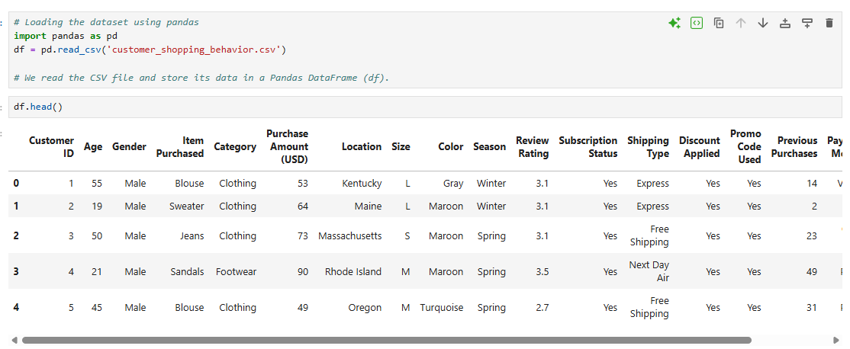
What we do:
- Import the Pandas library.
- Load the CSV file into a DataFrame named df.
- Display the first 5 rows to understand the dataset structure.
2. Checking Dataset Information
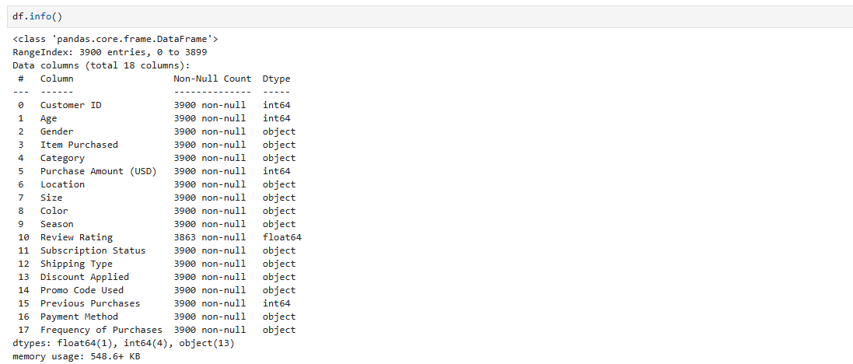
What we do:
- Check the number of rows and columns.
- Identify each column's data type.
- Check for missing values.
- Understand the overall structure of the dataset.
3. Checking Missing Values
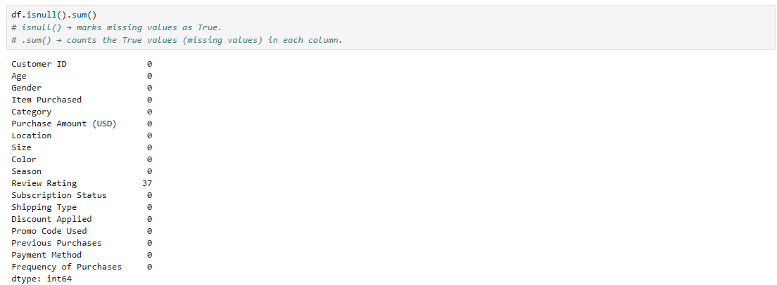
What we do:
- Count the number of missing values in each column.
- Identify which columns need data cleaning.
- We found 37 missing values in the Review Rating column.
4. Filling Missing Values
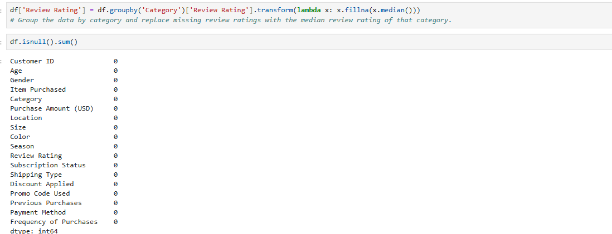
What we do:
- Group the data by Category.
- Calculate the median review rating for each category.
- Replace missing review ratings with the median value of that category.
- This preserves category-specific trends.

5. Renaming Column Names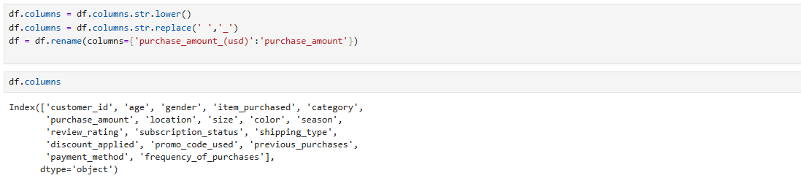
What we do:
- Convert all column names to lowercase.
- Replace spaces with underscores.
- Rename purchase_amount_(usd) to purchase_amount for easier coding.

6. Creating Age Groups
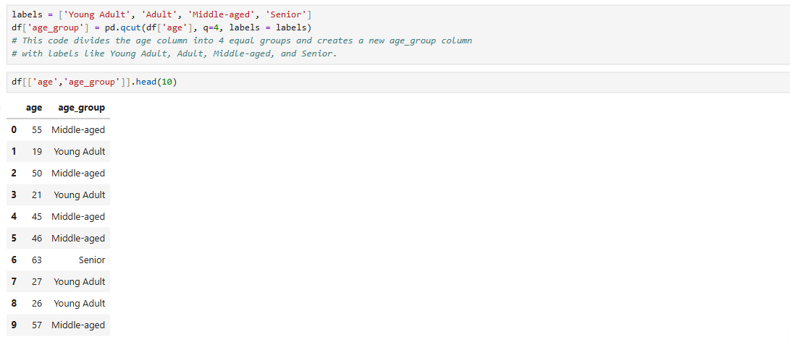
What we do:
- Divide customers into four equal age groups.
- Create a new column called age_group.
- This makes age analysis easier in visualizations.

7. Creating Purchase Frequency (Days) 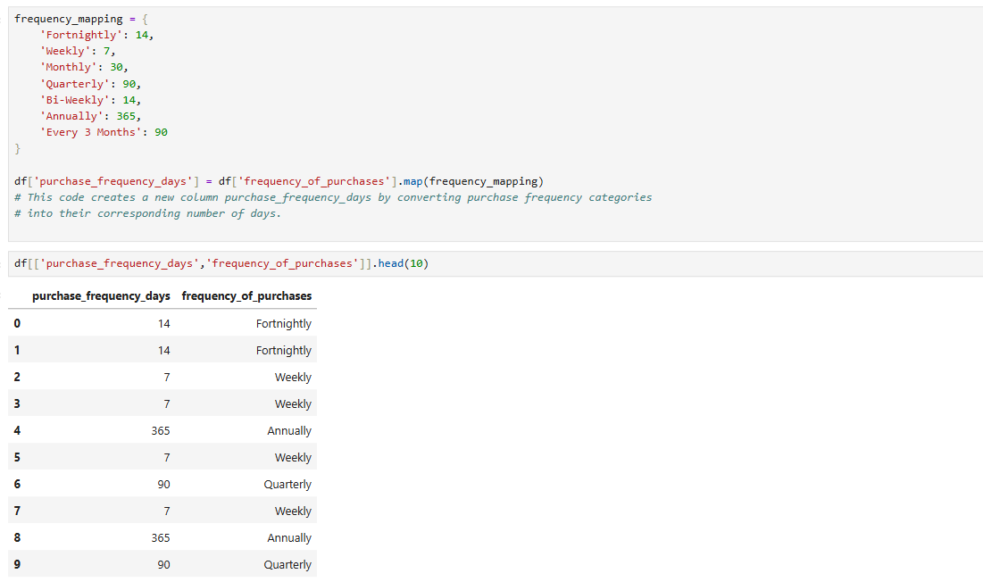

What we do:
- Convert purchase frequency categories into numeric values (days).
- Create a new column called purchase_frequency_days.
- This allows numerical analysis of purchase frequency.

8. Checking Duplicate Information
9. Removing Redundant Column
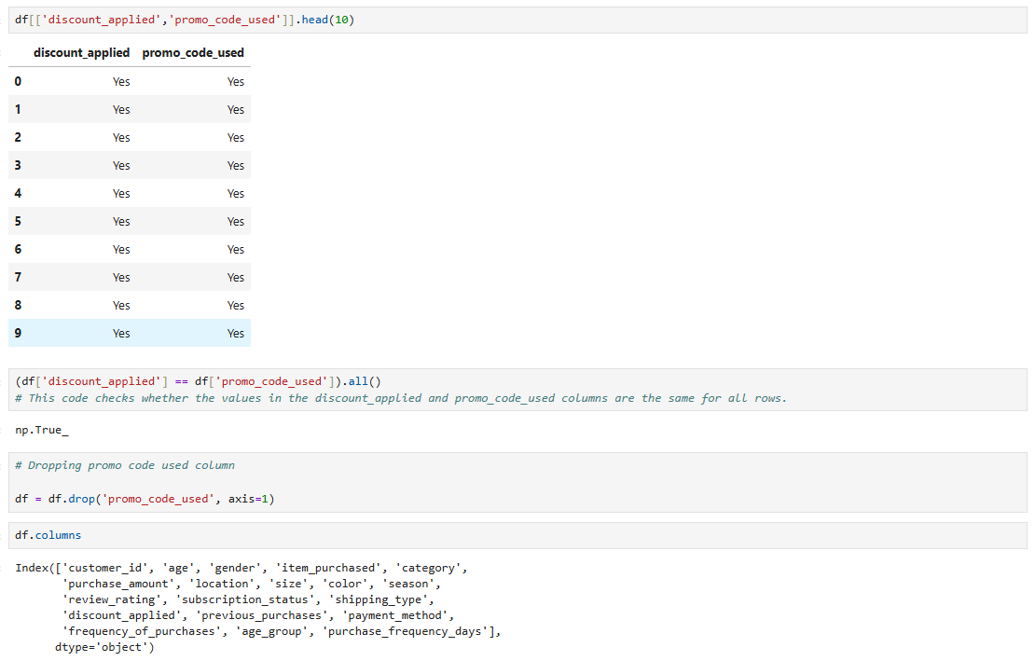

What we do:
- Compare the discount_applied and promo_code_used columns.
- Check whether both columns contain the same information.
- The result is True, meaning both columns are identical.
- Remove the promo_code_used column.
- Since it duplicates the discount_applied column, it is unnecessary.
- This reduces redundancy and keeps the dataset clean.

SQL Analysis Summary
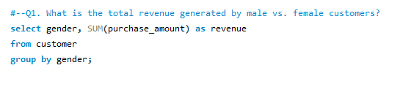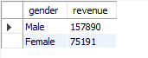
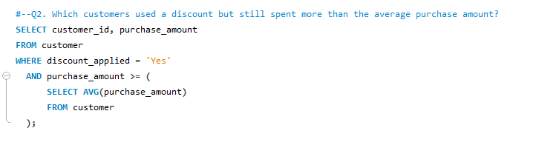
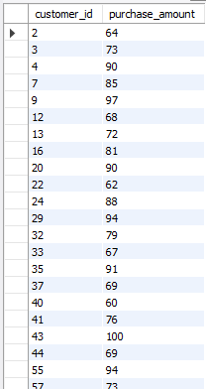
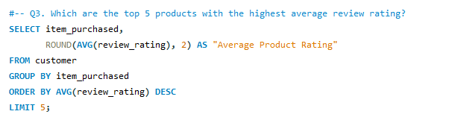
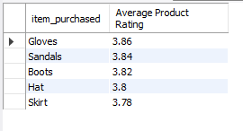
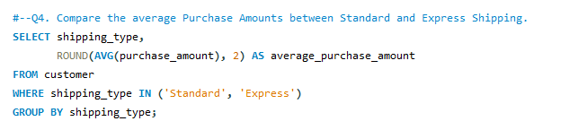
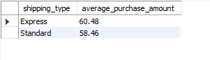
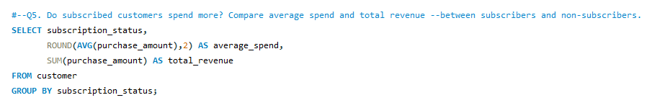
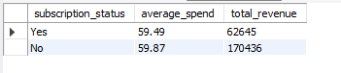
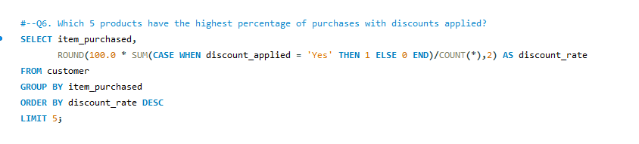
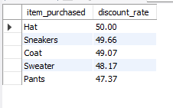
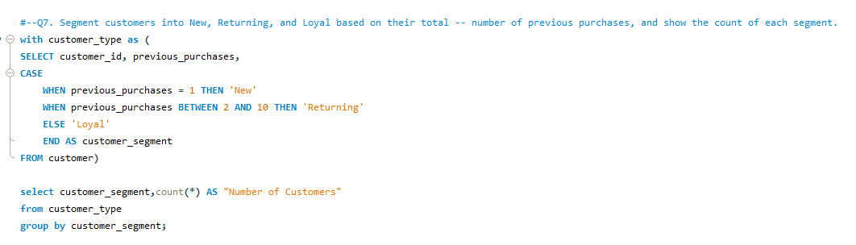
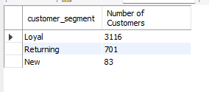
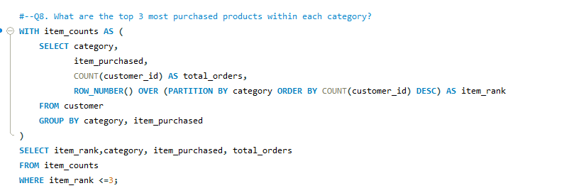
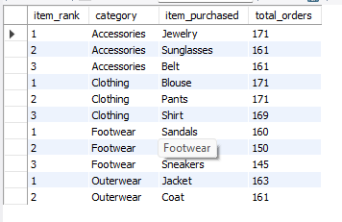
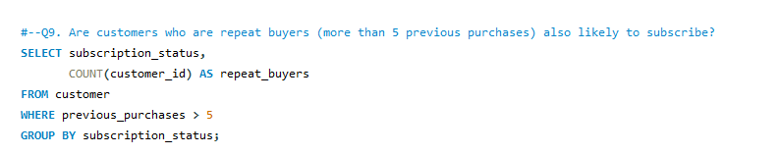
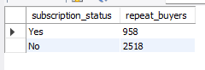
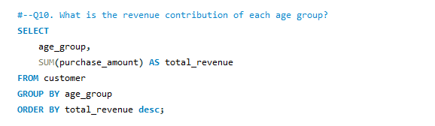
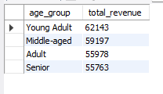

Conclusion of SQL Analysis
The SQL analysis was performed to convert raw customer shopping data into meaningful business insights. It helped analyze customer spending, product performance, subscription behavior, discount usage, customer segmentation, and revenue contribution. These insights support better business decisions and were used to create an interactive Power BI dashboard for data visualization and reporting.

An Interactive Business Intelligence Dashboard for Customer, Sales, and Revenue Analysis
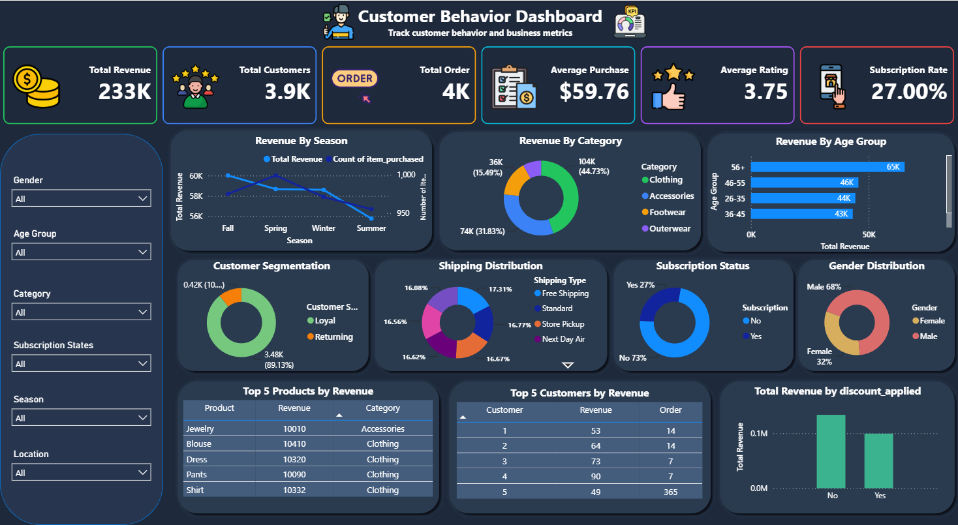

Dashboard Conclusion
The Customer Shopping Behavior Dashboard provides a comprehensive overview of customer purchasing patterns, revenue performance, and business metrics. The analysis shows that the business generated approximately 233K in total revenue from around 3.9K customers and 4K orders, with an average purchase amount of $59.76 and an average customer rating of 3.75.
The dashboard highlights revenue distribution across product categories, age groups, and seasons, while also providing insights into customer segmentation, shipping preferences, subscription status, and discount usage. Interactive filters allow users to analyze data by gender, age group, category, season, and location, making the dashboard dynamic and user-friendly.
Overall, this dashboard helps businesses identify high-performing products, understand customer behavior, evaluate marketing strategies, and support data-driven decision-making to improve sales, customer satisfaction, and business growth.

